1-Which one will be your project model waterfall, incremental or reuse-oriented development. Explain in details and why?

The online test system is the increasing development model.

Developing systems through the incremental version requires first providing basic operating functions, then providing system users with more advanced and more capable versions of the system at regular intervals. This model combines classical software lifecycle with iterative development at the level of system development organization. This is suitable for the provision of standard software maintenance contracts. Therefore, it is a popular software development model used by many commercial software companies and system vendor. This approach has also been extended by the use of software prototyping tools and techniques that provide direct support for incremental development and iterative release for early and ongoing user feedback and assessments.

2-Write full story of your project features (for each feature).

There are two different user entries on this shopping site. When the admin entry is made, it can make transactions in the shop for shopping. Admin can add categories to the site and edit them You can delete the added category, add products to the category You can edit the added products, identify your favorite products and brands within the products, see and control the sales

Customers who do not want to spend a long time to do shopping and in this direction, customers who want to carry out the shopping process in a fast and practical way, use the online shopping website of the store. In accordance with these procedures, users firstly provide their personal information to the site.

Then, the customers can check the details of the products they choose by easily listing the products according to their categories. They can add their products to the shopping cart and more sobnra can make shopping with the products in the basket

Customers can edit their profiles if they want to monitor the products they receive and keep the products in the basket for later purchase

3-Write detailed test case of your project features (for each feature).

Login:

1-Products are securely arranged with predefined admin entry.

2-Customers can register themselves as a cyclist.

Tests:

1-To test the visibility of product details for products

2-Testing of categories for products

Result:

As a result of the tests performed, customers can reach the details of each product and see the appropriate categories of products.

4-Write full requirements definition of your project.

User requirements:

1. E-commerce site customers can register themselves online.

2. During the registration or after the customers do the shopping process

System requirements

You must have a scanner installed on the electronic device you are using. Browsers like Internet Explorer, Chrome, Firefox

1.2. The latest version of the Flash player to open the system properly

must be installed in the system.

1.3. Each month's favorite product can be changed.

5. Write full nonfunctional requirements of your project.

Performance requirement:

In order to make purchases, user registration must be created.

The software will support the use of multiple users at once.

Availability:

The website should be user friendly and should make the least effort to use it.

Portability Need:

Web site is independent of the platform and can be moved to other servers with minimum effort HTML, CSS, JSP, PHP etc. It is done using.

Eligibility:

Customers can subscribe at any time and make purchases whenever they want.

This system should run on multiple operating systems and support the windows operating system

External requirements:

Card information and customer information will cause legal sanction in the purchases made in the system.

**6-Fill your project nonfunctional requirements metrics table.**

|  |  |
| --- | --- |
| Property | Measure |
| speed | Product purchase time |
| size |  |
| Ease of use | Product registration, shopping |
| reliability | Average downtime |
| robustness | ----- |
| portability | HTML, CSS, PHP, JSP |

**7-Write full requirements of each part of your project.**

The system must show the products in the correct categories and with appropriate details before each purchase.

System should know the products in the basket and according to it performs the shopping process.

**8-Write full structured requirements of each part of your project.**

Function: Customers' online shopping

Description: Provides time consuming and qualified shopping for customers without online shopping time

Entries: Provide customers' login ($ email, $ password)

Printouts: Exit the system using the Exit key.

Target: allows customers to order the products they have reviewed online.

Action: Provides the convenience to the customers with the functions that admin can perform on the site.

Requirement: Performance, usability, portability, usability

Side Effects: None

**9-Write tabular computation of your each function/model of your software.**

|  |  |
| --- | --- |
| Condition | Action |
| product in category(q>4) | Result =True |
| product in category(q<4) | Result =True |
| product in category(q<4) | Result =True |
| product in category (q=0) | Result = False |

**10-Write detailed scenarios for your project.**

First Assumption:

In the online shopping environment, valid keys are user names and passwords that can be customized. Information security is critical system required for the system administrator and the password is pre-defined.

Normal:

When customers enter the username and password correctly, the products designed for them enter the module web design. If the products on this page want to see the status of the products in our categories and pages, they can add to the basket and make purchases. Prepare the carts, adjust my carts, re-examine them and add to them.

What can go wrong:

If a non-registered customer wants to make purchases, this process cannot be performed, it needs to be registered first, and it needs to be clear about it. Users cannot change their mailing addresses later. It won't let you off again with the same ID.

**11. Draw use cases diagram for all use cases of your project like in chapter 4 page 65.**



Admin



Customer

**12. Draw full details context UML diagram of your project like in chapter 5 page 10.**

Product addition, extraction system

Customer system

Online shopping site

Category addition, extraction system

Admin system

**13. Draw fully detailed process model UML diagram of your project like in chapter 5 page 12.**

**14. Draw every use cases UML diagram of your project like in chapter 5 page 15.**

 

Data transfer

Customer Customer registration

**15.Prepare tabular description of your projects’ use cases like in chapter 5 page 16.**

|  |  |
| --- | --- |
| actor | Admin |
| description | The customer must open a new account or log into the existing account |
| data | Customer information and orders |
| stimulus | Command by online shopping site |
| Response comment | Admin must have the necessary security permissions to access customer information |

**16.Draw use cases of each agents’ use cases UML diagrams of your application like in chapter 5 page 17.**



17. Draw Sequence diagrams of every action in your project like in chapter 5 page 19-20.

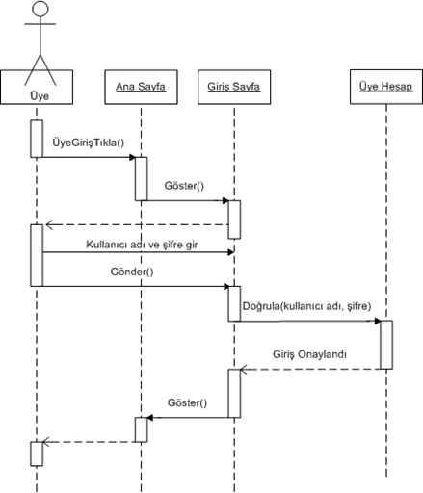

**18. Draw UML classes associations of all classes like shown in chapter 5 page 23-24.**

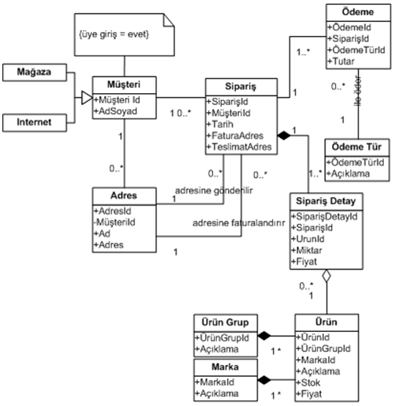

**19. Draw class models like shown in chapter 5 page 25.**

**20. Draw generalization hierarchy of your classes and all their details like shown in chapter 5 page 30-31.**

System

Unregistered customer

People

Admin

Users

Register customers

Users

E-mail

Password

Id

Admin

Controlling systems

**Unregistered customer**

Question answering

View results

**Unregistered customer**

Question answering

View results

**21. Draw aggregation associations of all your classes like shown in chapter 5 page 33.**

User Record

Products

Customer

Order

**22. Draw activity model of your application like shown in chapter 5 page 36**

Log In

e-mail

password

Register

View product

View

category

Product manufacture

Log Out

View Result

Order

**23. Draw your application processes like shown in chapter 5 page 37.**



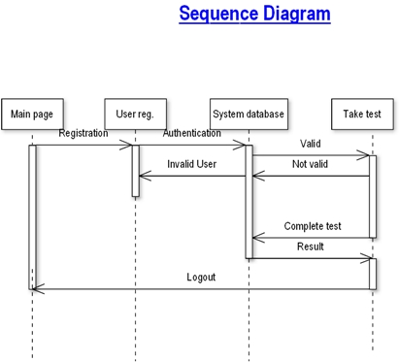

**24. Draw state diagram of your application like shown in chapter 5 page 40.**

Checking for Valid user

User registration

User Validation

Not Valid User

Valid User

Order control

**25. Prepare structured forms of your application’s states like shown in chapter 5 page 41-42.**

|  |  |
| --- | --- |
| Stimulus | Description: |
| Sign In | The user has signed in. |
| Sign Out | The user has signed out. |
| Home | The user has seen types of products. |
| History | The user has seen products. Products are ordered by customer. |
| Admin | Admin has signed in and has controlled system. |

|  |  |
| --- | --- |
| State | Description: |
| Developer | The user has seen developers. |
| Sign Feedback Out | The user has sent wishes and problems. |
| Order | The customer has seen ordered products. |
| Add product | The admin has seen added new product. |
| Add category | The admin has seen added new category. |
| Admin | Admin has seen users who they ordered product. |
| Feed | Admin has done feedback to user. |

**26. Draw the software architecture of your project like shown in chapter 6 page 42, 49.**

**INPUT PROCESS OUTPUT**

View Questions

View Answers

Update

Account

E-mail

Password

**User Database Use**

User Registration

Register User

Add Product

Search for User

View User Details

Add category

Update Customer

Added product

Added category

View product

Order product

View category

**27. Draw context diagram of your project like shown in chapter 7 page 9.**

Controlling System

**1 1**

**1 1..n**

Ordering Exam

Information of User

**1 1..n**

**28. Draw high level architecture of your project like shown in chapter 7 page 13.**

Subsystem

Management of Ordering

Subsystem

Management of Users

Subsystem

Management of Feedback

Online Shopping System

Subsystem

Management of Category

Subsystem

Management of Products

Subsystem

Management of Databese

**29. Draw all object classes of your project like shown in chapter 7 page 19.**